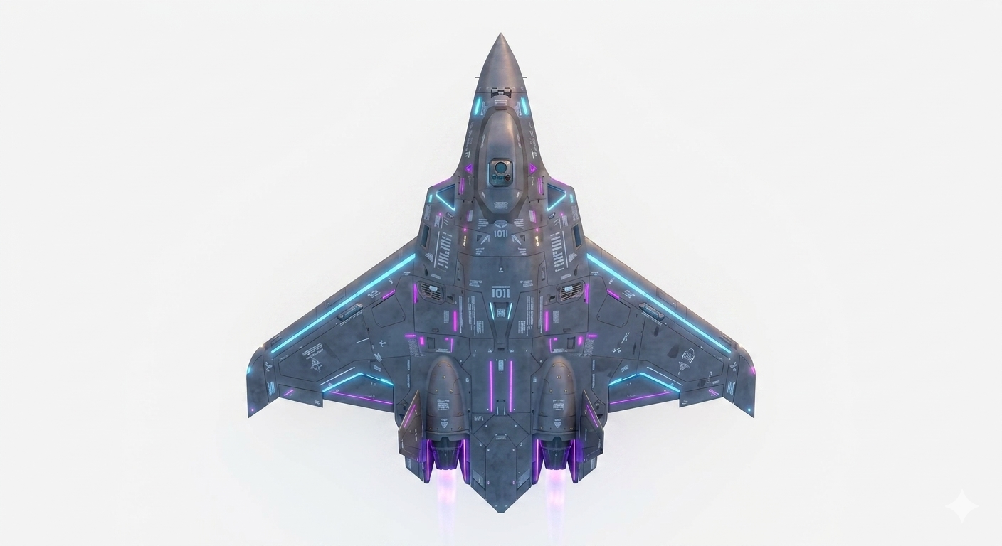
三角翼組裝檢查表
VERSION / 版本: V 0.01
EFFECTIVE DATE / 生效日期: 1 SEP 2026 / 2026年9月1日
Read & Do / 逐項閱讀並執行
[ ] = If Applicable / 適用(合格打勾)
Check clockwise from left to right & from back to front/順時針檢查由左至右由後至前
1. Basic Information / 基本資訊
1 | 機尾編號/ Tail Number: |  | Recheck  ☐
2 | 飛行地點(+經緯度)/light Location: |  | Recheck  ☐
3 | 場域大小(飛行場範圍)/ Field size: |  | Recheck  ☐
4 | 使用空域(+經緯度) /airspace used: |  | Recheck  ☐
5 | Date:  日期: |  | Recheck  ☐
6 | Time:  時間: |  | Recheck  ☐
7 | 執行人數:建議3-5人(視機種調整) |  | Recheck  ☐
8 | 組裝檢查員/Pre-Flight inspector: 組裝主管姓名/controller Name  技術人員/Technician:  1. 技術人員姓名/ Technician Name:  2. 技術人員姓名/ Technician Name:  3. 技術人員姓名/ Technician Name:  4. 技術人員姓名/ Technician Name:  5. 技術人員姓名/ Technician Name: | 組裝主管簽名/ Signature of the person who completed the final check: | Recheck  ☐

2. 準備與組裝程序 (PREPARATION)

1
2
3
5
4
6
項目 | 組裝與檢查程序 (Procedure) | 標準狀態 (Standard) | 確認 | 錯誤
1 | 組裝檢查表需與清單上進度一致(The assembly checklist must align with the schedule on the list.) | 是否嚴格執行(Whether it is strictly enforced) | ☐ | ☐
2 | 確認工具與零件規格是否一致(Confirm whether the specifications match) | 是否嚴格執行(Whether it is strictly enforced) | ☐ | ☐
3 | 於組裝場地進行組裝(Assembly is carried out at the assembly site.) | 供雙人以上作業使用 (For at least 2 Crew) | ☐ | ☐
4 | 組裝工作檯 (TakeOff Table) | 組裝、固定 (Assemble, Secure) | ☐ | ☐
5 | 機身根據工作檯標記定位 (Fuselage Positioned According to Table Markings) | 確認 (Confirm) | ☐ | ☐
6 | 查看組裝立體圖零附件是否無誤(如上圖)  (Check the assembly diagram and parts/accessories for accuracy.) | 確認 (Confirm) | ☐ | ☐
7 | 機翼連接桿穿過機身安裝 (Wing Joiners Fitted Through Fuselage) | 確認 (Confirm) | ☐ | ☐
8 | 左側機翼連桿連接至機身(The left wing strut connects to the fuselage.) | 確認 (Confirm) | ☐ | ☐
9 | 左側側翼連桿連接至機翼(The left-side flank link connects to the wing.) | 確認 (Confirm) | ☐ | ☐
10 | 機頭連桿連接至機身(The nose section connects to the fuselage via a connecting rod.) | 確認 (Confirm) | ☐ | ☐
11 | 右側機翼連桿連接至機身(The right-side wing strut connects to the fuselage.) | 確認 (Confirm) | ☐ | ☐
12 | 右側側翼連桿連接至機翼(The right-side flank link connects to the wing.) | 確認 (Confirm) | ☐ | ☐
13 | 左側機翼伺服機馬達接頭(Left wing servo motor connector) | 已連接、交叉檢查 (Connected, Crosschecked) | ☐ | ☐
14 | 右側機翼伺服機馬達接頭 (Right-wing servo motor connector) | 已連接、交叉檢查 (Connected, Crosschecked) | ☐ | ☐
15 | 左側機翼螺絲(Left wing screw) | 緊固 (Fasten) | ☐ | ☐
16 | 右側機翼螺絲(Right-side wing scre) | 緊固 (Fasten) | ☐ | ☐
17 | 左側三角翼下連桿確認:長度是否與機翼平行(Left-side delta wing lower link verification: Check if the length is parallel to the wing.) | 已組裝裝上 (Assembled) | ☐ | ☐
18 | 左側機翼伺服機馬達點位是否正確(Is the position of the left wing servo motor correct) | 連接 (Connect) | ☐ | ☐
19 | 右三角翼下連桿確認:長度是否與機翼平行(Right delta wing lower link verification: Check if the length is parallel to the wing) | 已組裝裝上 (Assembled) | ☐ | ☐
20 | 右側機翼伺服機馬達點位是否正確(Is the position of the right-wing servo motor correct) | 連接 (Connect) | ☐ | ☐
21 | 機頭螺絲(Pan-head screw) | 緊固 (Fasten) | ☐ | ☐
22 | 無刷馬達是否安裝正確(Is the brushless motor installed correctly) | 確認 (Confirm) | ☐ | ☐
23 | 無刷馬達螺絲(Brushless motor screws) | 緊固 (Fasten) | ☐ | ☐
24 | 馬達槳葉(Motor propeller blades) | 已安裝固定 (Installed) | ☐ | ☐

3. 一般機體外觀檢查 (GENERAL)
項目 | 檢查部位 (Item) | 預期標準狀態 (Standard) | 確認 | 錯誤
1 | 左側機翼結構 (LH Wing) | 無損壞、乾淨無阻 (Clear) | ☐ | ☐
2 | 右側機翼結構 (RH Wing) | 無損壞、乾淨無阻 (Clear) | ☐ | ☐
3 | 起落架結構 (Undercarriage) | 無損壞、乾淨無阻 (Clear) | ☐ | ☐
4 | 機身主體結構 (Fuselage) | 無損壞、乾淨無阻 (Clear) | ☐ | ☐
5 | 所有防護罩/保護蓋(All protective shields/covers) | 已確認安裝固定(Installed) | ☐ | ☐
6 | 空速管(Pitot tube) | 已確認安裝固定(Installed) | ☐ | ☐
7 | GPS | 已確認安裝固定(Installed) | ☐ | ☐
8 | 無刷馬達(Brushless motor) | 已確認安裝固定(Installed) | ☐ | ☐
9 | 馬達槳葉(Motor propeller blades) | 已確認安裝固定(Installed) | ☐ | ☐
10 | 酬載確認是否已固定及配重是否達標(Verify that the payload is secured and the counterweight meets the required specifications) | 確認 (Confirm) | ☐ | ☐
— 檢查表全項結束 (END OF CHECKLIST) —

