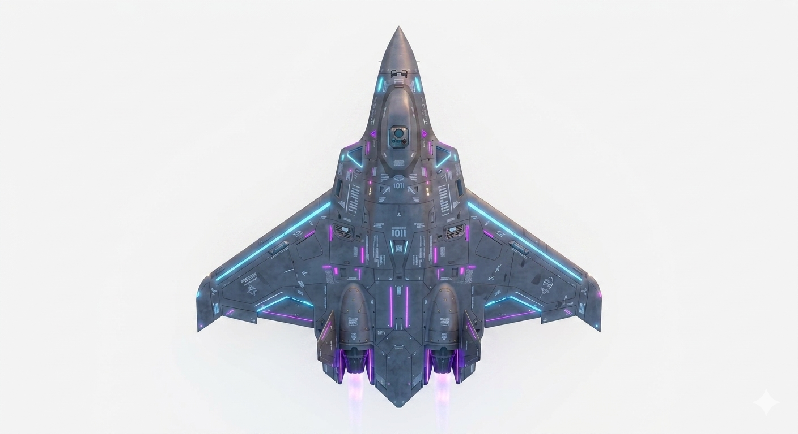
三角翼飛行後檢查
版本 (VERSION): V 2.0
生效日期 (EFFECTIVE DATE): 3 April 2023
閱讀並執行 (Read & Do)
□ = If Applicable / 適用(合格打勾)
Check clockwise from left to right & from back to front/順時針檢查由左至右由後至前
1. DETAILS / 詳細資訊
1 | 機尾編號/ Tail Number:
2 | 飛行地點(+經緯度)/light Location:
3 | 場域大小(飛行場範圍)/ Field size:
4 | 使用空域(+經緯度) /airspace used:
5 | 起飛方式(跑道、拋飛、彈射架)/ takeoff method(runway、throw、catapult):
6 | 天氣預報/ Weather forecast(幾度風幾浬)
7 | 跑道方向/ runway direction:(風向及地點決定起飛方向)
8 | 落地方式(跑道、攔截網、降落傘)/Landing method(Runway、interception net、Parachute):
9 | Date:  日期:
10 | Time:  時間:
11 | 執行人數:建議2-3人(視機種調整)
12 | 飛行前檢查員/Pre-Flight inspector: 飛手姓名/controller Name  技術人員/Technician:技術人員姓名/ Technician Name | 最終檢查完成者簽名/ Signature of the person who completed the final check:

2. 降落安全檢查 (SAFETY)
1 | 地面站上鎖/ Ground station locked | 已上鎖/Disarmed | □
2 | 測量飛行前後電瓶電壓壓降/ Measure the voltage drop of the battery before and after flight | Before: ( )V  After: ( )V | □
3 | 拔除電池連接/ Disconnect the battery | 已斷電/Disconnect | □
4 | 將無人機體移離跑道至試車區/ Move uav to the runup area | Check Area Markings  檢查區域標記 | □

3.一般項目 (GENERAL)
1 | 360°目視檢查機體有無鳥擊或其他受損/360° visual inspection of the aircraft for bird strikes or other damage. | 無鳥擊無損傷/No Bird strikes and Undamaged | □
2 | 空速管/ pitot tube(視飛機設計更改) | 無堵塞損毀/ No blockage or damage | □

飛行後360°檢查

6. 左機翼 Left WING
1 | Wing (Leading Edge, Upper, Trailing Edge, Lower)  機翼 (前緣、上部、後緣、下部) (航行燈?)左紅右綠 | Undamaged  無損壞 | □
2 | Ailerons (Both) (Upper, Trailing Edge, Lower)  副翼(上部、後緣、下部) | Undamaged  無損壞 | □
3 | Flap(Upper, Trailing Edge, Lower)  襟翼(上部、後緣、下部) | Undamaged  無損壞 | □
4 | Wing Tip LED  翼尖閃光(防撞)燈 | Undamaged  無損壞 | □
5 | Servos  伺服馬達 | Undamaged  無損壞 | □
6 | Servo Covers (Covers 0.3 Nm Torque) (看飛機設計更改)  伺服馬達護蓋 (護蓋 0.3 Nm 扭力) | Secure  穩固 | □
7 | Servo Push Rods  伺服推桿 | Undamaged, Not Bent  無損壞，無彎曲 | □
8 | Servo Arms  伺服擺臂 | Undamaged  無損壞 | □
9 | Control Surface Horns  控制面角 | Undamaged, Secure  無損壞，穩固 | □
10 | Pushrod Clips  推桿夾 | In Place, Secure  就位，穩固 | □
11 | 右主輪外觀/ Right main tire appearance | 正常無破損/Normal Undamaged | □
12 | 右輪擋/ Right wheel chocks | 擋妥/Installed | □

10. 飛行員攝影機(機頭位置)/ Pilot camera(Nose position)
1 | Support & Cover  支架與護蓋 | Undamaged, Secure  無損壞，穩固 | □
2 | Camera  攝影機 | Aligned Correctly  對齊正確 | □
3 | Camera Lens  攝影機鏡頭 | Clean and Undamaged  乾淨無損壞 | □
4 | Camera Lens  攝影機鏡頭 | No Fog, Moisture or Residue  無起霧、濕氣或殘留物 | □
6 | 鼻輪外觀/ Nose tire appearance | 正常無破損/Normal Undamaged | □
7 | 輪擋/ wheel chocks | 擋妥/Installed | □
8 | 鼻輪轉向/nose wheel steering | 作動正常/Normal | □

11. 右機翼 Right WING
1 | Wing (Leading Edge, Upper, Trailing Edge, Lower)  機翼 (前緣、上部、後緣、下部) (航行燈?)左紅右綠 | Undamaged  無損壞 | □
2 | Ailerons (Both) (Upper, Trailing Edge, Lower)  副翼(上部、後緣、下部) | Undamaged  無損壞 | □
3 | Flap(Upper, Trailing Edge, Lower)  襟翼(上部、後緣、下部) | Undamaged  無損壞 | □
4 | Wing Tip LED  翼尖閃光(防撞)燈 | Undamaged  無損壞 | □
5 | Servos  伺服馬達 | Undamaged  無損壞 | □
6 | Servo Covers (Covers 0.3 Nm Torque) (看飛機設計更改)  伺服馬達護蓋 (護蓋 0.3 Nm 扭力) | Secure  穩固 | □
7 | Servo Push Rods  伺服推桿 | Undamaged, Not Bent  無損壞，無彎曲 | □
8 | Servo Arms  伺服擺臂 | Undamaged  無損壞 | □
9 | Control Surface Horns  控制面角 | Undamaged, Secure  無損壞，穩固 | □
10 | Pushrod Clips  推桿夾 | In Place, Secure  就位，穩固 | □
11 | 右主輪外觀/ Right main tire appearance | 正常無破損/Normal Undamaged | □
12 | 右輪擋/ Right wheel chocks | 擋妥/Installed | □

13.馬達及螺旋槳/Motor and propellers
1 | 馬達(小心高溫)/Motor(careful the high temperature) | Rotates by Hand、Secure, Undamaged  可用手轉動、穩固，無損壞 | □
2 | 底座固定/ Base fixed | 螺絲鎖緊/Tighten screws | □
5 | All Torque Seals(看飛機設計更改)  所有扭力標記 | Aligned  對齊 | □
6 | Propeller & Blade  螺旋槳與葉片 | Secure, Undamaged  穩固，無損壞 | □
7 | Propeller  螺旋槳 | Rotates by Hand  可用手轉動 | □
8 | Propeller Attachment Bolts Torque Seals (Remove Spinner to Check, Bolts 9.5 Nm Torque)  螺旋槳連接螺栓扭力標記 (拆下整流罩檢查，螺栓 9.5 Nm 扭力) (看飛機設計更改) | Aligned  對齊 | □
9 | Spinner  螺旋槳整流罩 | Aligned, Undamaged  對齊，無損壞 | □
10 | Spinner Connection Screw  整流罩連接螺絲 | Tight, No Play  鎖緊，無間隙 | □
11 | Standoff, Vibration Mounts  支柱，減震墊 | Undamaged, Not Hard, No Cracks  無損壞，未硬化，無裂縫 | □
12 | All Torque Seals  所有扭力標記(看飛機設計更改) | Aligned  對齊 | □
13 | 電線連接/ Wire connection | Undamaged, Not Loose, Properly Seated  無損壞，未鬆動，正確就位 | □

酬載(武掛)檢查/payload (Armored) check
1 | 靜電接地（ESD）防護/ Electrostatic discharge (ESD) protection | 已連接/ Connected | □
2 | 檢視地面站「武器安全狀態」/ Inspect the ground station's "weapon safety status" | 安全鎖定/ DISARMED | □
3 | 檢查掛架（Pylon）與鎖扣結構 / Inspect the hanger (Pylon) and latching mechanism. | 無鬆動、無金屬疲勞裂紋/ No loosening, no metal fatigue cracks | □
4 | 酬載物外觀/payload Appearance | Undamaged, Secure  無損壞，穩固 | □

飛行紀錄
1 | Download the flyrecord data from memory card/從記憶卡上下載飛行數據紀錄 | Downloaded/已下載 | □

